Тема: Достопримечательности США
Цель: расширение словарного запаса, самостоятельная работа со словарём
Задание 1: Прочитайте и письменно переведите текст на русский язык

The Statue of Liberty
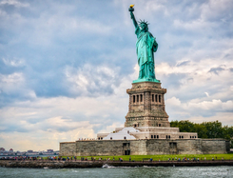 | The Statue of Liberty is located on Liberty Island in New York. In 1886 American people got it as a gift from the French. Since that time the statue has been the symbol of freedom and of the United States.  The height of the Statue of Liberty is 93 metres (from ground level to torch). Visitors can admire the view of the harbour from its crown.

The White House
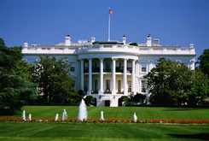 | The White House is the official residence of the President of the USA. It is located in Washington. The building consists of 6 floors with different rooms including living space and halls for official receptions.  George Washington was the only American president who didn't live in the White House. When he was the President, the White House did not exist.  The White House was built in 1800. The famous Oval Office where the President of the USA works is located here.

Niagara Falls
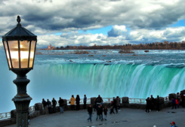 | Niagara Falls are located on the border between Canada and the USA. "Niagara Falls" is a common name for three waterfalls – the American Falls, the Horseshoe Falls and the Bridal Veil Falls.  Niagara Falls are not very high (53 metres) but very wide.  Every year thousands of people visit this scenic place. There is the Rainbow Bridge over the river which connects both countries. It is open for pedestrians.

The Golden Gate Bridge
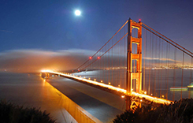 | The Golden Gate Bridge is a world-famous bridge over the Golden Gate strait. It is one of the most recognisable places in the world and the symbol of the USA.  Its length is 2,7 km. The bridge was built in 1937 and connects San-Francisco and Marin County.

The Grand Canyon
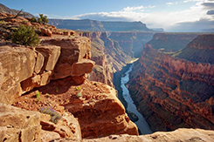 | The Grand Canyon is one of the deepest canyons in the world. Its depth is 1800 metres. It is located in Arizona on the territory of the national park. The length of the canyon is 446 km and its width varies from 6 to 29 km at the top and is less than 1 km at the bottom.  The Grand Canyon is a very picturesque place. Every year thousands of tourists come here. Nowadays visitors can admire the canyon from the observation point called "Grand Canyon Skywalk".

Times Square
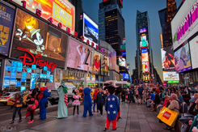 | Times Square is a square in the centre of Manhattan. It is not only the symbol of New York but the USA as well. Times Square is one of the most visited places of interest in the world. A lot of Broadway theatres are located in it. A lot of big companies also have their offices there.  Times Square is full of bright neon advertisement which makes it a very recognisable place.

The Empire State Building
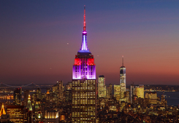 | The Empire State Building is a famous skyscraper in New York. This building was the tallest building in the world for a long time. It has 103 floors. There are two observation decks in the building (on floors 86 and 102).  The height of the building is 443 metres. 73 lifts serve it. The Empire State Building is designed in a simple but elegant style. It is one of the symbols of American culture. The Empire State Building is an office building.

Hollywood
 | Hollywood is a neighbourhood in Los Angeles. It is known as the home of the US film industry. A lot of film production studios are located here. For example, film studio "Paramount Pictures" is based in Hollywood. Many celebrities live in this neighbourhood.  The Hollywood Walk of Fame is also located in Hollywood. It comprises more than 2600 stars.

Задание 2: Напишите не менее семи предложений, какое из этих мест вы хотели бы посетить и почему.
Срок сдачи до 03.12.21; выполненные задания присылать на почту mimikrio@mail.ru, указав в теме фамилию и номер группы.

